EXPERIMENT 5
Vacuum Cleaner Problem

Question
Write a Python program to solve the Vacuum Cleaner problem
Aim
To write a Python program to implement a Vacuum Cleaner intelligent agent that identifies and cleans dirty rooms.
Algorithm
- Start with two rooms, A and B.
- Check the current room.
- If the room is dirty, clean the room.
- If the room is clean, move to the other room.
- Check the condition of the other room.
- Clean the room if it is dirty.
- Continue until both rooms are clean.
- Display the final status of the rooms.

Code
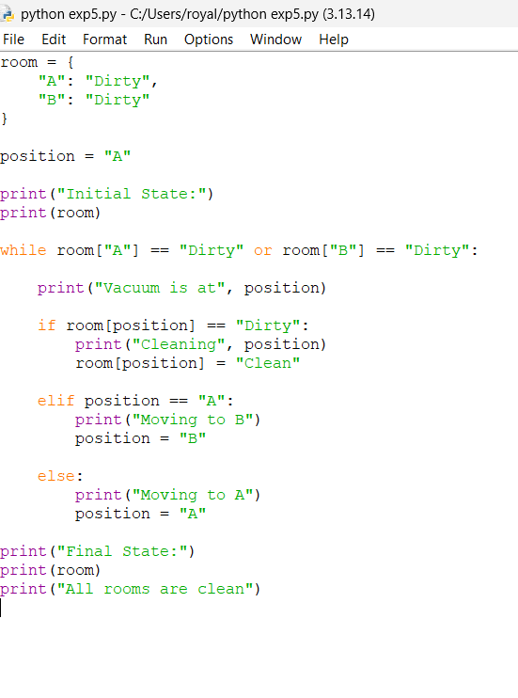

Output
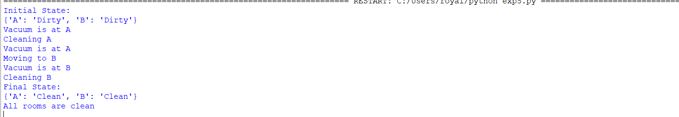

Result
Thus, the Vacuum Cleaner problem was successfully implemented using an intelligent agent, and all dirty rooms were cleaned.

